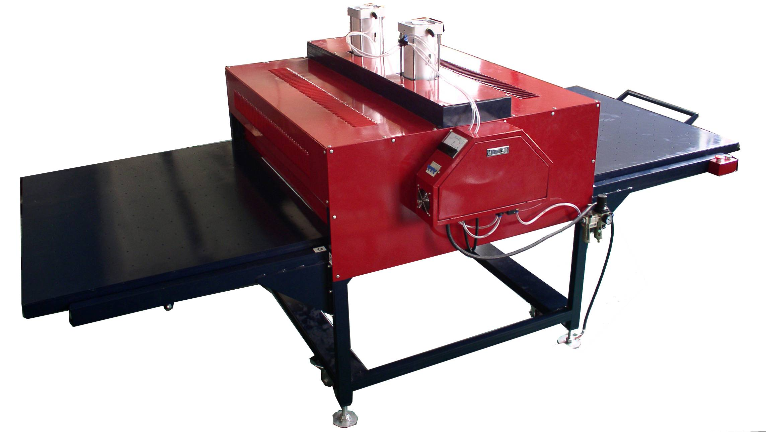


Working table
Heating board
Wheel
Temp clock
Cylinder
Time clock

Start button
Pressure adjust
power
Pressure clock
Machine body

技术参数
咨询
中国广东深圳
天府东街 30 号
电话：(0571) 45557788
传真：(0571) 45556750
www.adatum.com

Specification:

Using special technology, automatic working, easy to handle, safe and reliable

2. Ticker and larger aluminum heating board make sure heating more even, suitable for large size printing

Summarization：

It could transfer colorful photos/words on cotton, fiber and so on.

Automatic Heat Press Machine HTM-LCB4

Attention

1. We have 380V and 220V voltage,when you order,please confirm your voltage first
2. You need to check “Waterspout” whether have water when you using the machine for a while,if it have water,then please drain the water,then tighten the water drain switch
3. Please do not touch the heating board,or it will injure your fingers.
4. You need to test t-shrit first to get right temp,pressure,time,and best printing effect also connect with depth of t-shirt and types of transfer paper
5. The function of the clocks is complex,so please do not adjust other function,you only need to set temp and time,or the it will affect your using!!!

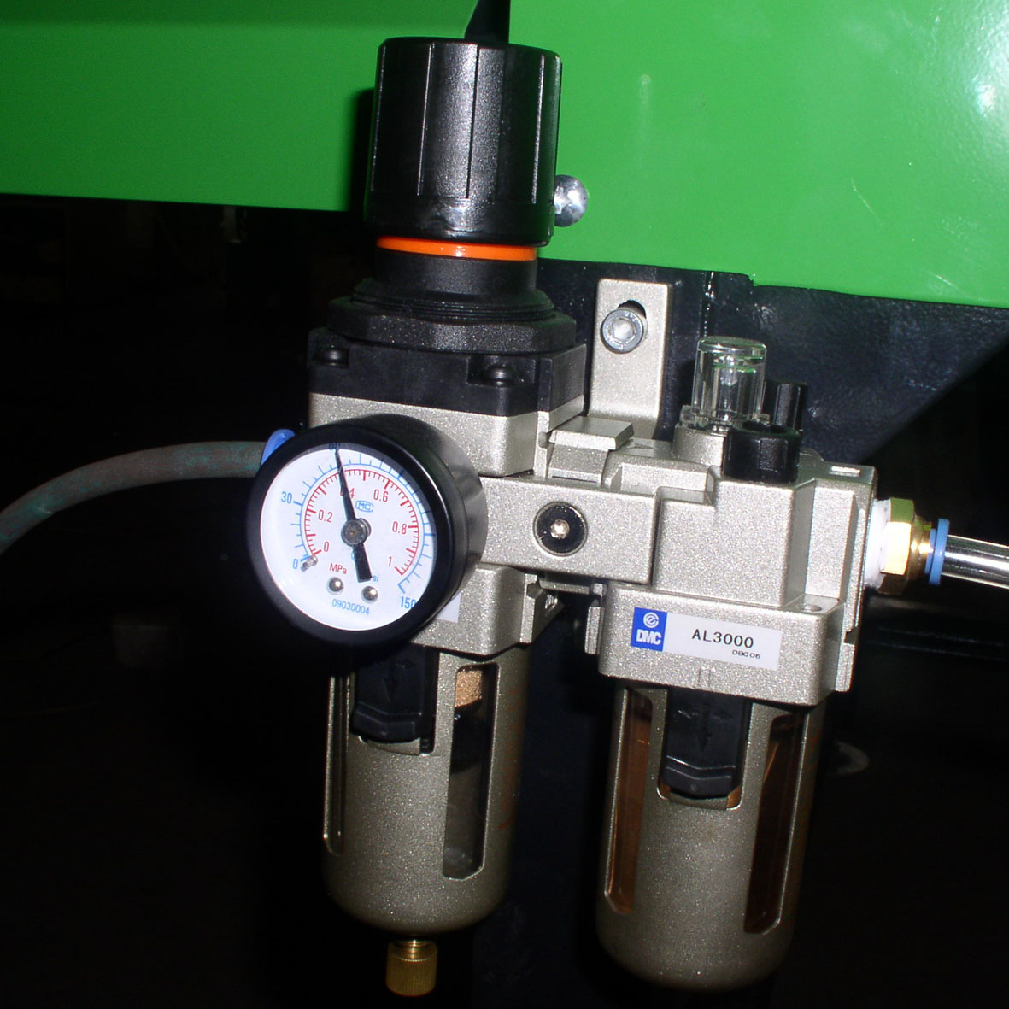
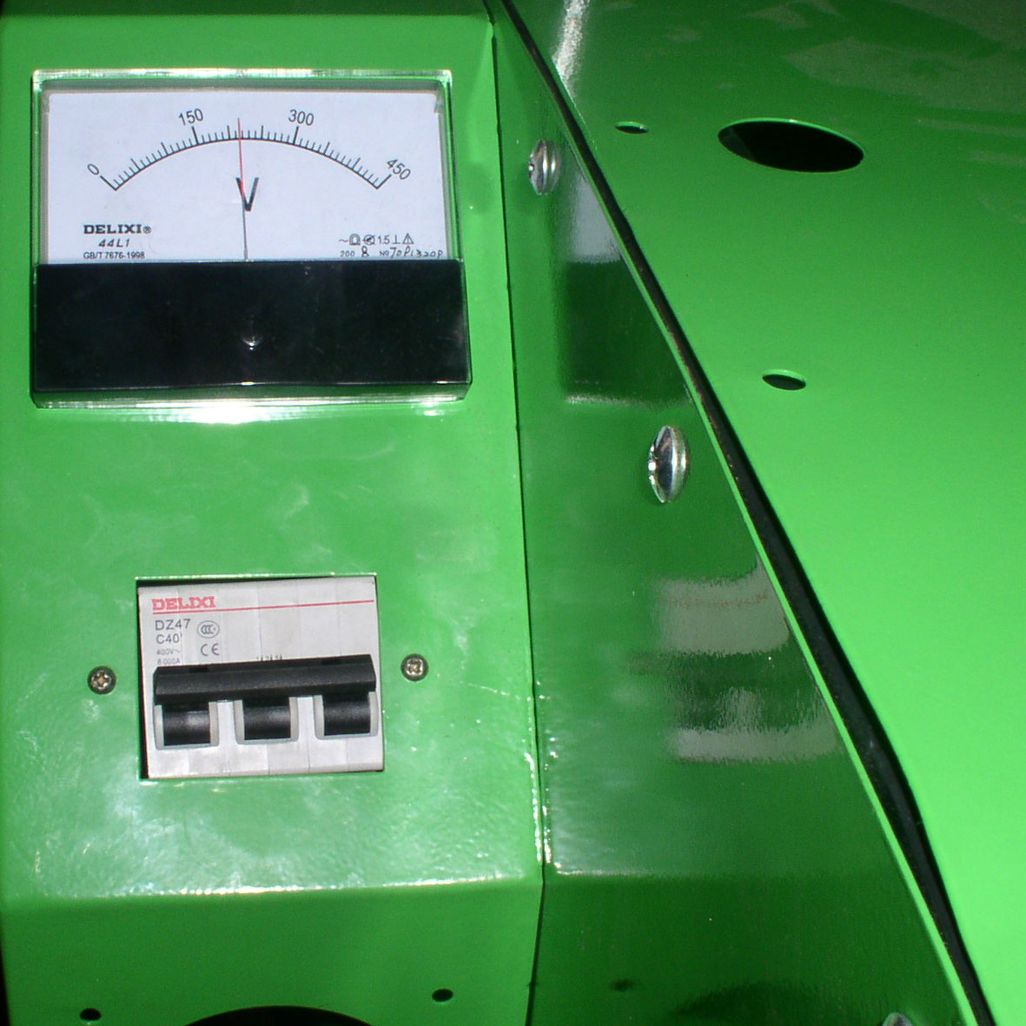
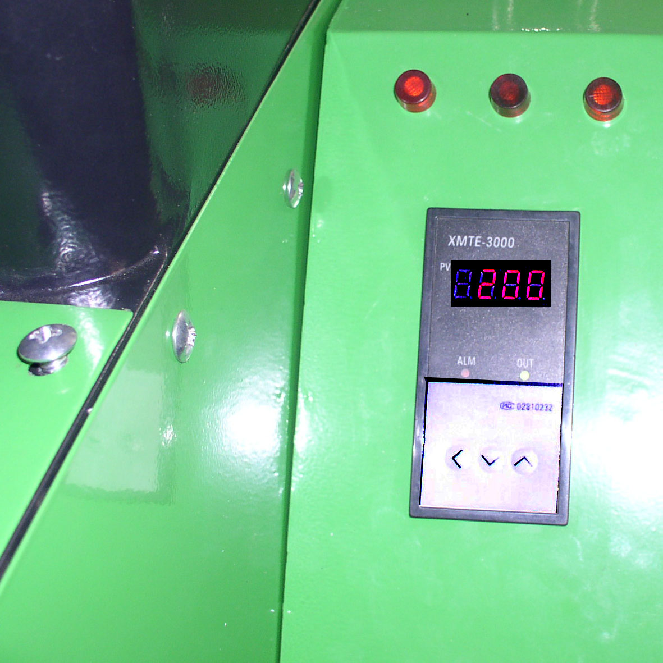
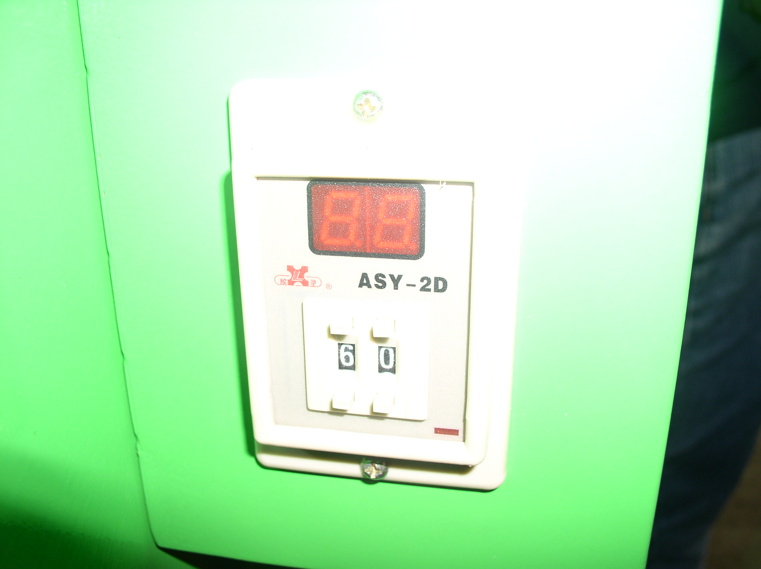
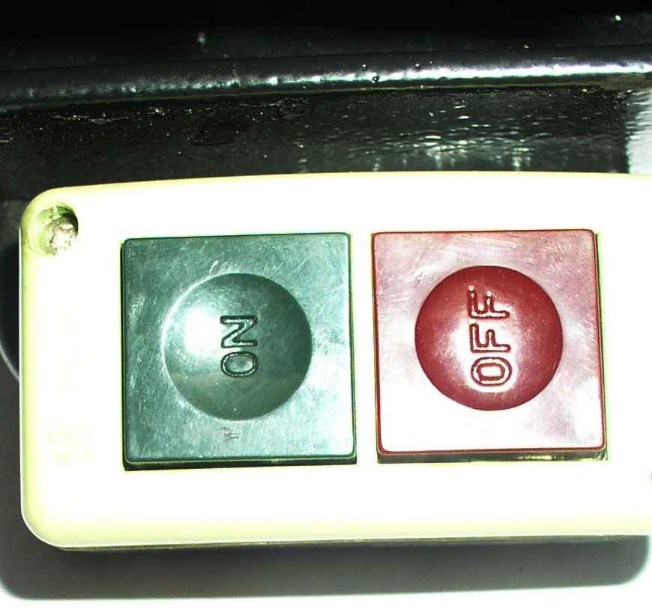
Pull up “Pressure adjust valve”, Clockwise for add pressure, anticlockwise for decrease pressure. When you get right pressure, then close “Pressure adjust valve”
Take out “working table”,turn on power

Temp clock display when heating, pressor botton to set temp you need(usually need 100-250 celsius), when reaching temp you set,then you could start printing(usually need about 1 hours for rising temp)
Set the right time(usually 5-20 sec), put the printing materials on working table, make it flatly, then push the working table under heating board
Press “startup button”

Heating board will close automaticly, when reaching time you set it will rising up, then you could pull out working table
You could also put printing materials on the other side of working table, so you could continue printing with two working tables.

Before using:

You need to adjust the machine on flat position using “bottom adjuster”
Connect the air compressor,turn on power,then adjust “Pressure adjust valve”(usually 3-6kg/cm2) until the heating board rising up automaticly.

Manul

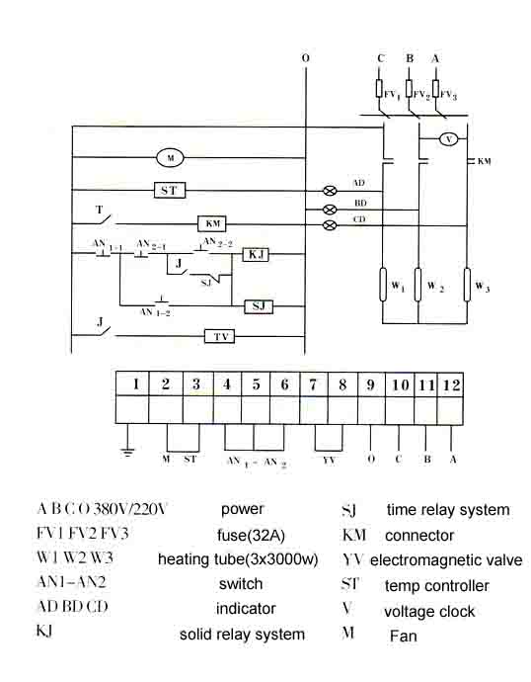
Heating board not work: 1. power plug whether connect
2. indicator light whether function
3.fuse whether burn in Electric box
4.if the light for fuse box function,then you need to change the same type of fuse

Cylinder not work:1.check pressure clock whether have pressure
2. Electromagnetism valve
Whether work when you press Startup Button

Problems and Solve

Voltage：380V/220V
Power：9KW
Temp range：0-399 celsius
Time range：0-60sec/0-30sec
Printing area：80cmX100cm/100cmX120cm, 100*200cm
Cylinder distance：125cm
Largest pressure：8kg/cm2
Net weight：490kg/ 625kg
Package size ： 1000mmX1400mmX1600mm

Parameter

